Project Development Phase
User Acceptance Testing (UAT) Execution & Report Submission – Metro Ticket Generating System
Date | 05 September 2026
Project Name | Metro Ticket Generating System
Maximum Marks | 4 Marks

1. Purpose of Document
The purpose of this document is to record the UAT coverage and implementation evidence available for the Metro Ticket Generating System at the time of release to User Acceptance Testing. The supplied screenshots are used as the test evidence.

2. UAT Test Case Analysis
S.No. | Test Case / Scenario | Expected Result | Evidence | Status
1 | Open Book A Metro Ticket catalog item | Ticket booking form loads with configured fields. | Screenshot 12 | Pass
2 | Select Starting Form and Going To | Station reference values can be selected/displayed. | Screenshot 12 | Pass
3 | Select Single/Return journey | Journey type can be selected. | Screenshot 12 | Pass
4 | Enter number of passengers | Passenger count is accepted and used by fare logic. | Screenshots 9 & 12 | Pass
5 | Fare auto-calculation | Fare field is calculated by the Fare auto-calculation client script. | Screenshot 9 + Screenshot 12 | Pass
6 | Select payment mode | Payment mode options are available. | Screenshot 12 | Pass
7 | Enter payment mode when required | Payment mode entry field is shown/required according to the Catalog UI Policy. | Screenshot 7 + Screenshot 12 | Pass
8 | Submit booking / QR generation | Metro ticket QR code is generated and displayed. | Screenshots 10 & 11 | Pass
9 | Verify catalog configuration | Variables and catalog item configuration are present. | Screenshots 5 & 6 | Pass
10 | Verify table and access configuration | Application table and CRUD access controls are configured. | Screenshots 1–3 | Pass

3. Defect Analysis
No separate defect log or severity-wise defect counts were included in the supplied screenshots. To avoid inventing test data, the defect statistics below are recorded as 'Not Provided'.
Resolution | Severity 1 | Severity 2 | Severity 3 | Severity 4 | Subtotal
By Design | N/P | N/P | N/P | N/P | N/P
Duplicate | N/P | N/P | N/P | N/P | N/P
External | N/P | N/P | N/P | N/P | N/P
Fixed | N/P | N/P | N/P | N/P | N/P
Not Reproduced | N/P | N/P | N/P | N/P | N/P
Skipped | N/P | N/P | N/P | N/P | N/P
Won't Fix | N/P | N/P | N/P | N/P | N/P
Totals | N/P | N/P | N/P | N/P | N/P

4. UAT Evidence Screenshots
Evidence 1 – ServiceNow application table list.
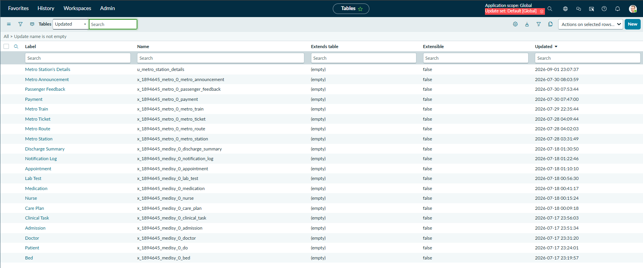
Evidence 2 – Metro Station's Details table configuration and columns.
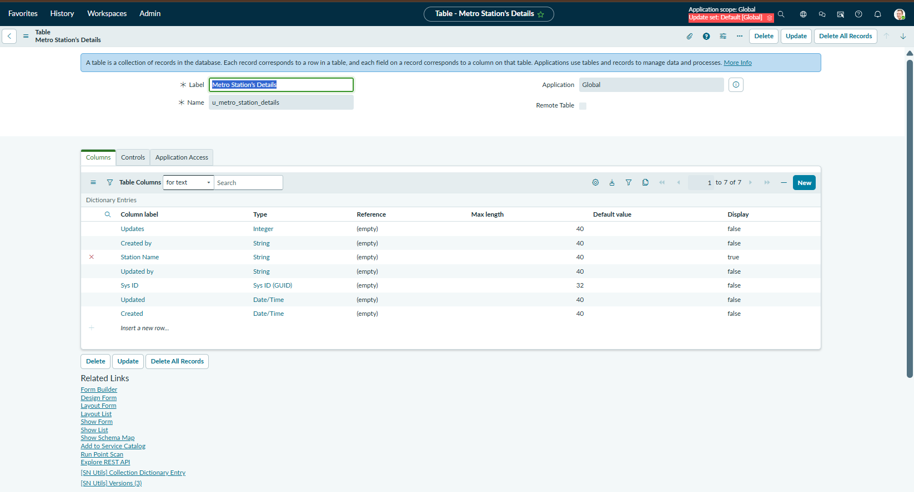
Evidence 3 – Table access controls for create/read/delete/write.
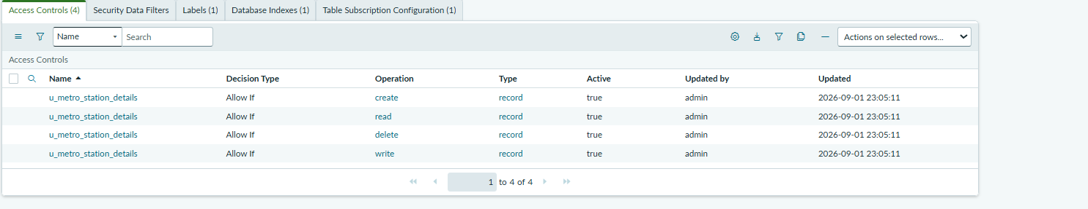
Evidence 4 – Service Catalog list showing Book A Metro Ticket.
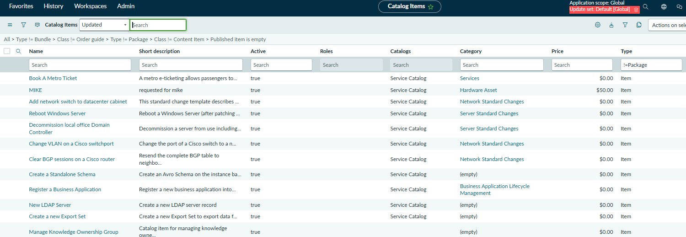
Evidence 5 – Book A Metro Ticket catalog item configuration.
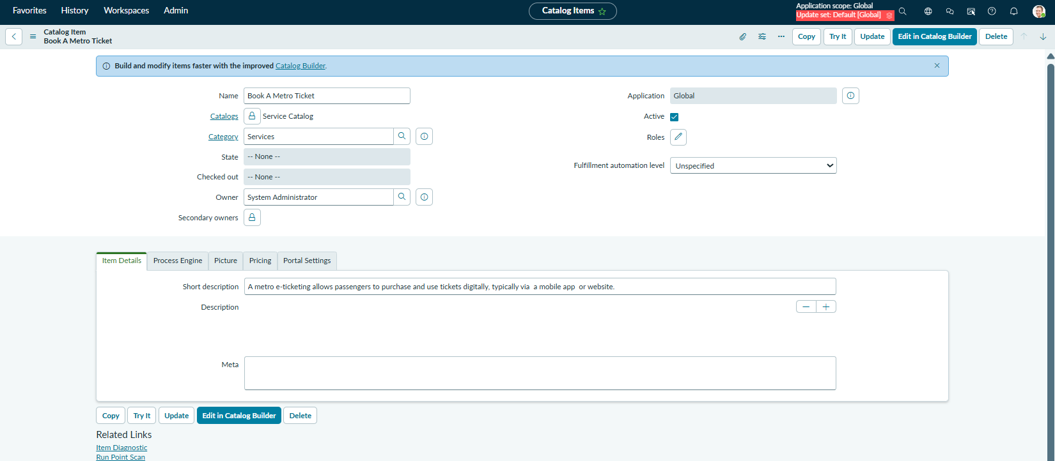
Evidence 6 – Ticket booking variables.
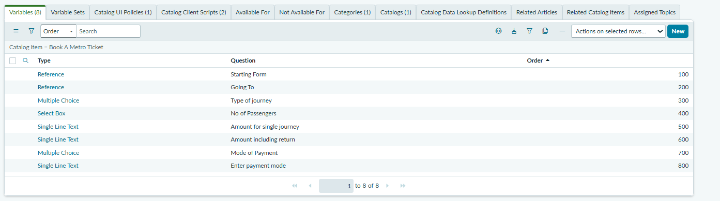
Evidence 7 – Catalog UI Policy and policy action.
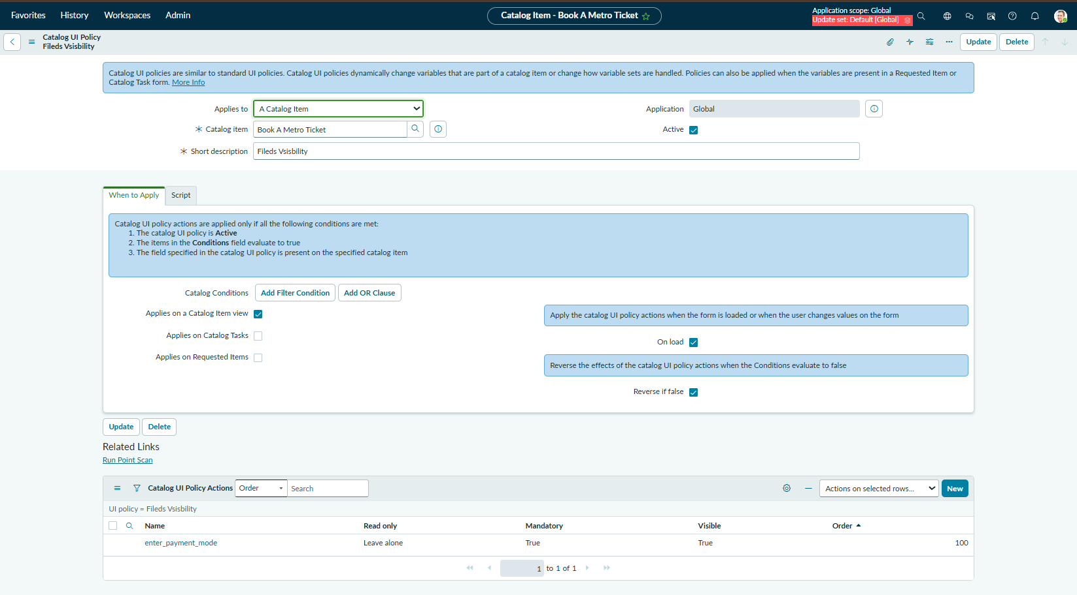
Evidence 8 – Catalog Client Scripts list.
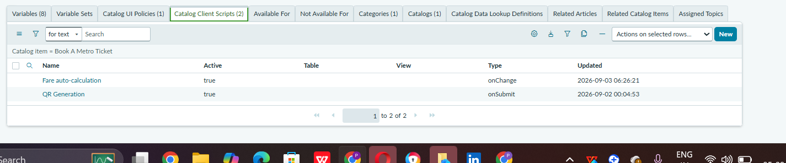
Evidence 9 – Fare auto-calculation script.
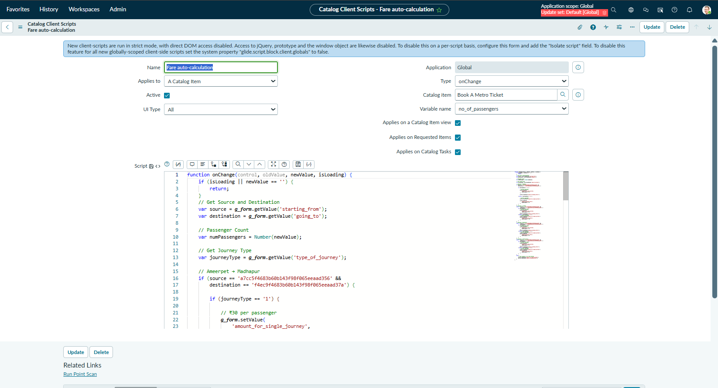
Evidence 10 – QR Generation script.
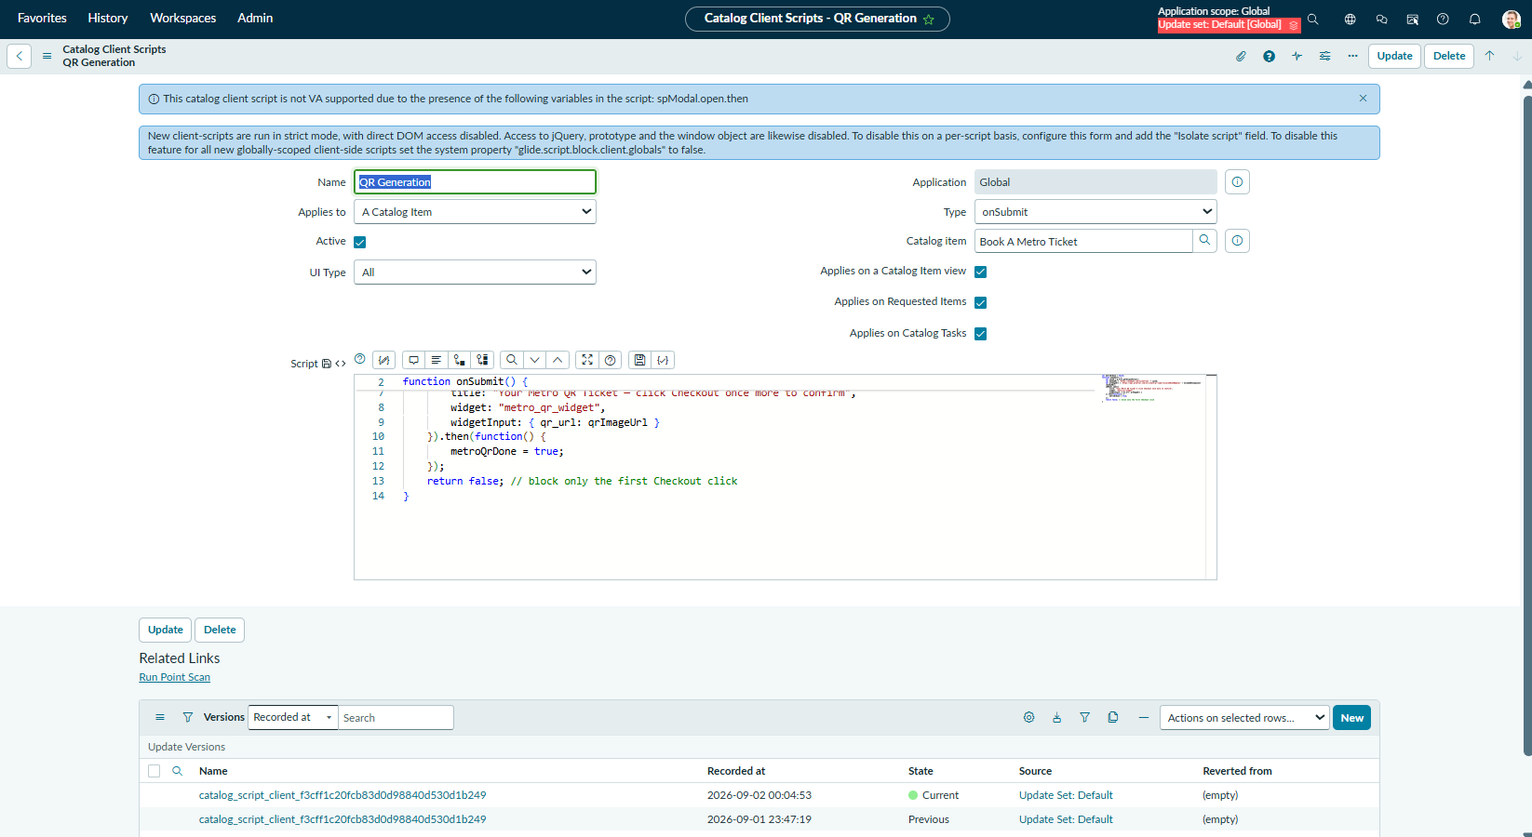
Evidence 11 – Generated Metro Ticket QR Code.
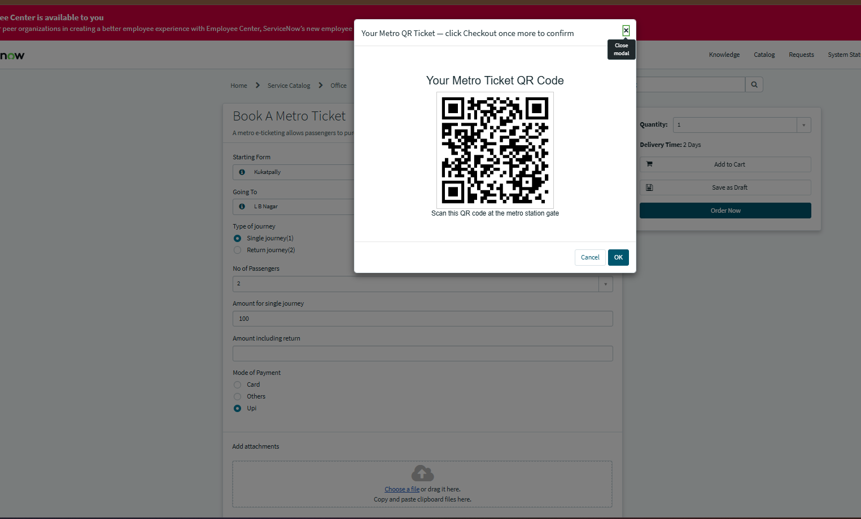
Evidence 12 – Ticket booking form with entered test data.
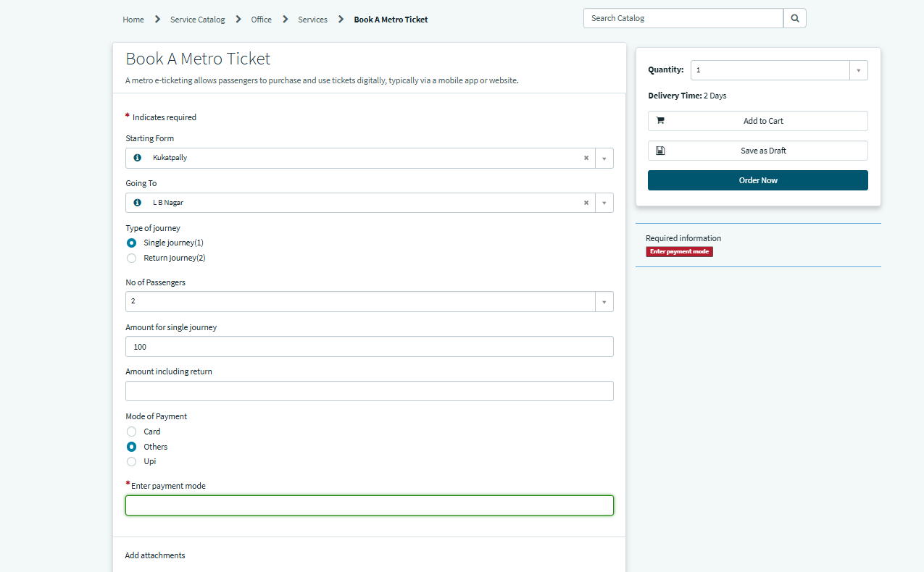

5. UAT Summary
Based on the supplied implementation screenshots, the core ticket-booking flow is evidenced from catalog configuration through fare calculation and QR-code generation. Formal defect counts, tester names/signatures, and an independent UAT approval record were not supplied and therefore are not fabricated in this document.

